**Trig/Precalc Quiz Review #2 Name:**

**Evaluate each expression using your unit circle.**

1. sec 180° 2. sin 45° 3. cos

4. 5. 6.

**Simplify each expression**

7.  8. (cos2 x)(sec x)(tan x)

9. 10..

**Verify each identity.**

11.cos (90 - ) = sin  12. csc2 = cot2 + sincsc

13.  14. sec x csc x = tan x + cot x

15. Solve for all real values of x.

16. Solve for principal values of x. Express the solution(s) in degrees.

17. Solve

18. Solve

19. Solve for all real values of x.

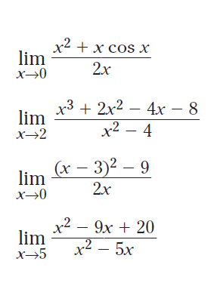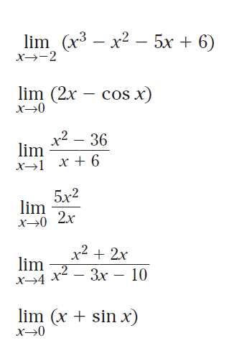**Evaluate each limit**

20. 21.

22. 23.

24. 25.

26. 27.

28.

29.