Geometry: Name:________________________
Chapter 8 Test Review Date:_________ Hour:___________

Find the sum of the measures of the interior angles of each convex polygon.
1. 36-gon 2. 11-gon

The measure of the interior angle of a regular polygon is given. Find the number of sides in each polygon.
3. 171 4. 108

For 5-6, find the measures of an interior angle and an exterior angle given the number of sides of a regular polygon. Round to the nearest tenth.
5. 16 6. 38

7. Find the sum of the measures of the 8) A convex octagon has interior angles with
…..exterior angles of a 109-gon. … measures (x + 55)°, (3x + 20)°, (4x)°,
….(4x – 10)°, (6x – 55)°, (3x + 52)°, (3x)°, and ….(2x + 30)°. Find x.

Determine whether each quadrilateral is a parallelogram. Justify your answer.
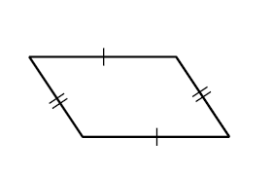
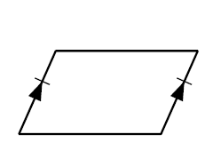
9. 10. 11.
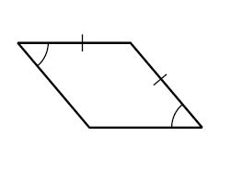

Determine whether a figure with the given vertices is parallelogram. Use the method indicated.
12. X(3, 0), Y(3, 8), Z(-2, 6), and W(-2, -2); Slope Formula

13. A(-3, 2), B(-1, 4), C(2, 1), D(0, -1); Distance and Slope Formulas

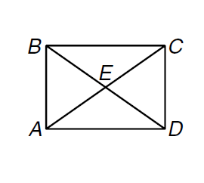
ABCD is a rectangle.
14. If AE = 36 and CE = 2x – 4, find x.

15. If $m∠BAC=7x+1 and m∠CAD=9x-7, find m∠BAC.$

Determine whether ABCD is a rectangle given each set of vertices. Justify your answer.
16. A(6, 2), B(2, 10), C(-6, 6), D(-2, -2) 17. A(-3, 1), B(-3, 3), C(3, 3), D(3, 1)

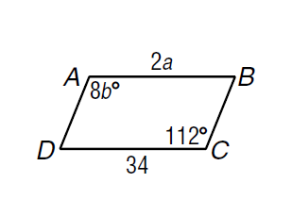
18. Find a and b in parallelogram ABCD.

19. ABCD is a parallelogram with diagonals that intersect at E. If BE = 2x + 6 and ED = 5x – 12,
find BD.

20. In parallelogram ABCD, $m∠1=x+25, and m∠2=2x. Find m∠2 and m∠ABC.$
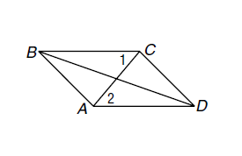

Find the measure of each interior angle.
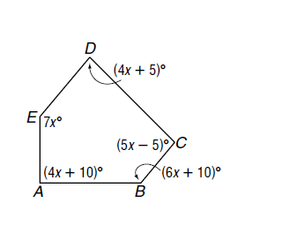
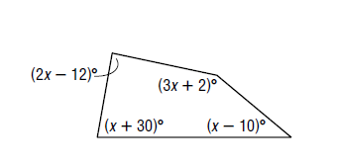
21. 22.

Answer the following questions by determining if each statement is always, sometimes, or never true.
23. A square is a parallelogram 24. A rhombus is a square
25. A quadrilateral is a parallelogram 26. A rectangle is a rhombus
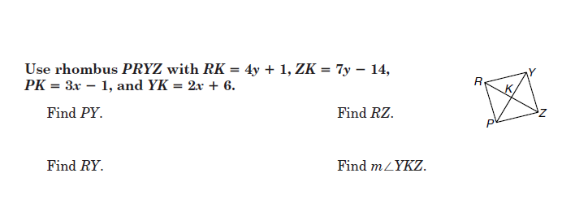
27. A quadrilateral that is a rectangle and a rhombus is a square.

29.
28.

30.
31.
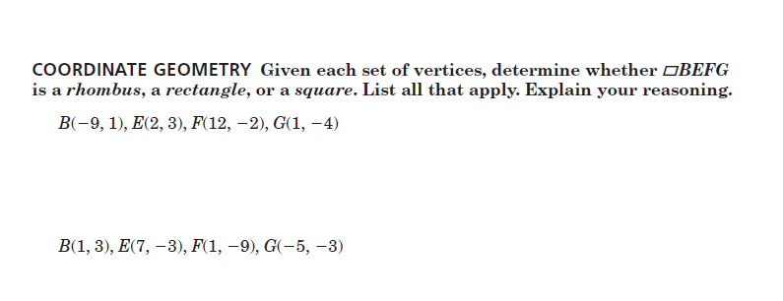

32.

33.

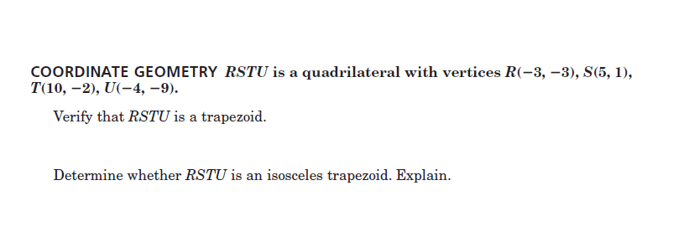
34.

35.
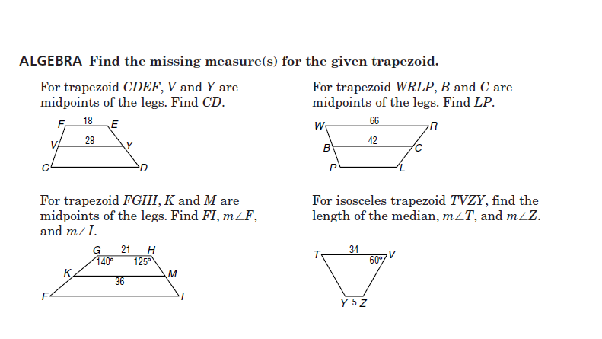

37.
36.

39.
38.

40. Find x if the bases of a trapezoid have lengths 2x + 4 and 8x – 10 and the length of the ….. median is 3x + 21.

