Chapter 10 Review Name:
Geometry
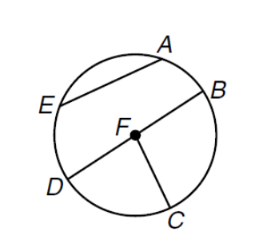
Use the picture to the right for #1-5.
1. Name the circle: ______ 2. Name a radii of the circle: ______
3. Name a major arc: ______ 4. Name a minor arc: ______
5. If BD = 8 inches what is FC?
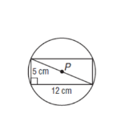

6. What is the exact circumference of $⊙P?$

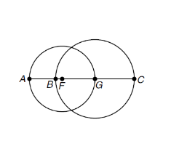
The diameters of $⊙F$ and $⊙G$ are 8 and 10 units, respectively. Find each measure.
7. BF 8. AB

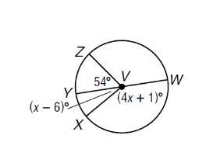

9. In $⊙V$, $\overline{YW}$ is a diameter. Find each measure.
$m∠XVW$ = ______ $m∠ZVW$= ______
$m\hat{YX}$= ______ $m\hat{XW}$= ______
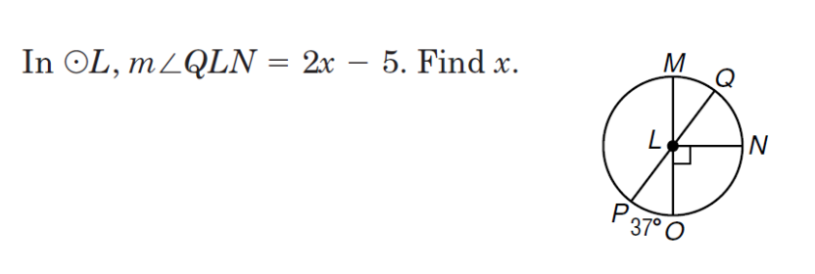
10.

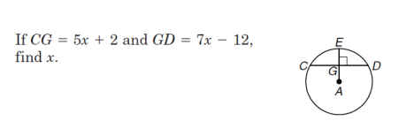
13.

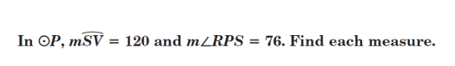
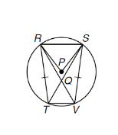
14.

$m∠PRS$ = ______ $m\hat{RSV }$= ______
$m\hat{RT}$= ______ $m∠RVT$= ______
$m∠QRS$= ______ $m∠STV$= ______
$m\hat{TV}$= ______ $m∠SVT$= ______

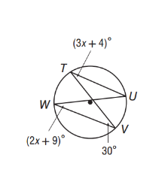
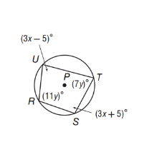
Find each measure.
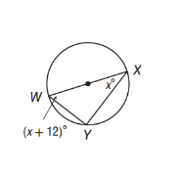
15. $m∠W, m∠U$ 16. $m∠W, m∠X$ 17. $m∠R, m∠S$

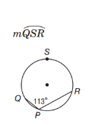
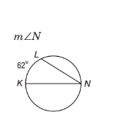
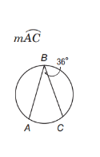
18. 19. 20.

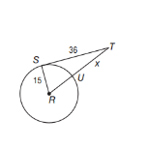
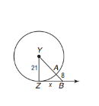
Find x. Assume that segments that appear to be tangent are tangent.
22. 23.

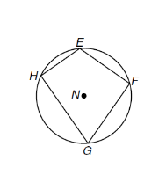
24. Quadrilateral EFGH is inscribed in $⊙N$ such that $m\hat{FG}=102, m\hat{GH}=120, m\hat{EHG}=180$. Find each
measure.
$m∠E$ = ______ $m∠F$ = ______
$m∠G$ = ______ $m∠H$ = ______

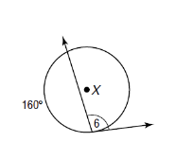
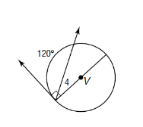
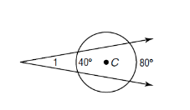
Find each measured angle that is labeled.
28. 29. 30.

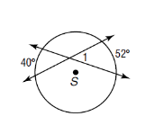
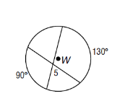
31. 32.

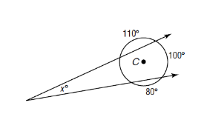
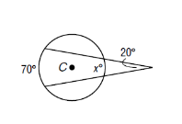
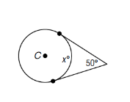
Find x.
33. 34. 35.

Write an equation for each circle.
36. center at (-7, 11), r = 8 37. center at (12, -9), d = 22

38. a circle with center at (-5, 3) and a radius with endpoint (2,3)

39. a circle whose diameter has endpoints (4, 6) and (-2, 6)
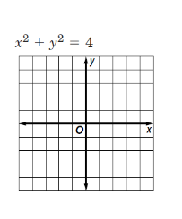
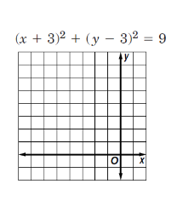
Graph e ach equation.
40. 41.

